**\*\*\*Maintain this folder Structure\*\*\***

**main_folder/**

**├─ boiler_plate/**

**│ ├─ shared/**

**│ │ ├─ SharedResource/**

**│ │ │ ├─ common/**

**│ ├─ slide/**

**│ │ ├─ css/**

**│ │ ├─ img/**

**│ │ ├─ js/**

**├─ images/**

**├─ output/**-(output folder is generated after first execution)

**├─ data.xlsx**

**├─ eD-Tool_V2.1.exe**

If any of the folder mentioned above not present. Please create empty folder with same name.

**Usage:**

1. **Copy all images to 'images' folder.**

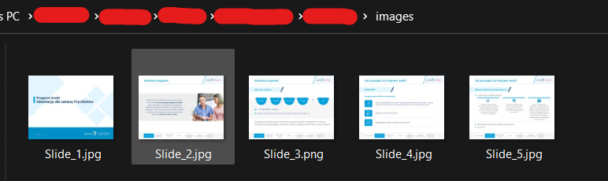

1. **Set data in 'data.xlsx' with Mysheet id & project name.**
2. Enter only in one cell like shown in example.

1. Enter key messages if required. Else keep all row as ‘**Slide’.**

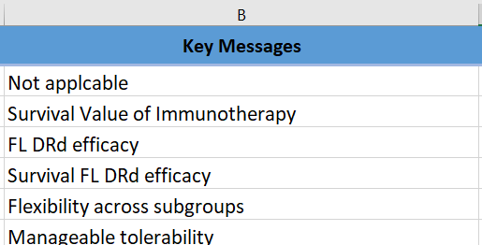

1. Enter images name with extension. If carousal is present separate with commas. Don’t put extra commas.

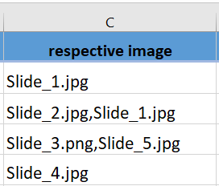

1. If popups are present. Enter corresponding to the main slide. For multiple popups separate it with commas. Leave cell empty if not present.

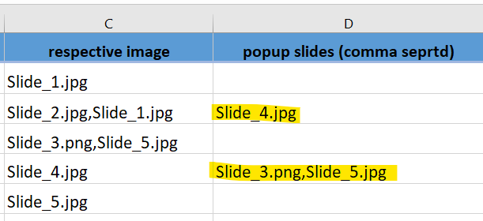

1. For buttons needed enter here

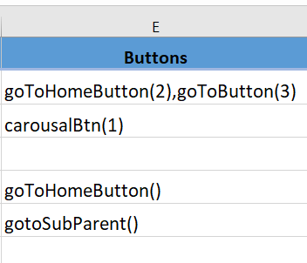

**Available buttons** (syntax: **ButtonName(No. of buttons)**):

* + goToButton()
  + goToHomeButton()
  + gotoSubParent() – this will ignore No. of buttons as parameter
  + carousalBtn()

**Eg: goToButton(5) : will create 5 goTo buttons inside the main slide html like shown below** (css will not be generated. You can use class name which has generated)

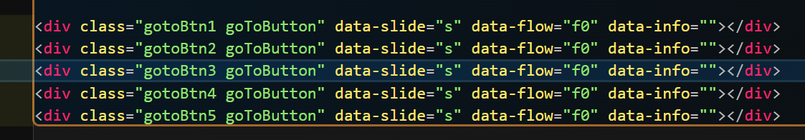

1. **Save the excel file.**
2. **Run the exe file and wait for output folder to generate. Prompt box will come to notify when completed.**
3. **After successful execution all files will present in output folder**